CIFAR-10 Representation Learning Benchmark
Comparative Study of CNN, MAE, and I-JEPA Backbones
Group 5

1. Introduction
Deep learning models rely heavily on the quality of learned feature representations. While supervised learning directly optimizes representations using labels, recent self-supervised learning approaches aim to learn transferable representations without requiring annotation.
In this project, we benchmarked three representation learning paradigms on the CIFAR-10 dataset:
- ResNet18 (CNN) – Fully supervised representation learning.
- Masked Autoencoder (MAE) – Reconstruction-based self-supervised learning.
- Image Joint Embedding Predictive Architecture (I-JEPA) – Predictive self-supervised learning.
The quality of learned representations was evaluated using:
- Linear Probing
- Fine-Tuning / LoRA Adaptation

2. Dataset
CIFAR-10 consists of 60,000 RGB images belonging to 10 classes.
Property | Value
Training Images | 50,000
Test Images | 10,000
Classes | 10
Resolution | 32 × 32
Channels | RGB

Classes:
- Airplane
- Automobile
- Bird
- Cat
- Deer
- Dog
- Frog
- Horse
- Ship
- Truck

3. Experimental Setup
3.1 CNN (ResNet18)
- Backbone: ResNet18
- Learning Paradigm: Supervised
- Epochs: 50
- Evaluation:
  - Linear Probe
  - Fine-Tuning

3.2 Masked Autoencoder (MAE)
Encoder Configuration:
- Patch Size = 4
- Embedding Dimension = 192
- Transformer Depth = 12
- Attention Heads = 3
- Mask Ratio = 0.75
Training Configuration:
- MAE Pretraining = 50 Epochs
- Linear Probe = 20 Epochs
- LoRA Fine-Tuning = 15 Epochs

3.3 I-JEPA
- Backbone: ViT-H/14
- Hidden Dimension: 1280
- LoRA Rank: 16
- LoRA Alpha: 32
- LoRA Dropout: 0.05
Evaluation:
- Linear Probe
- LoRA Fine-Tuning

4. Results
4.1 CNN Results
Protocol | Accuracy (%)
Supervised Training (Best Validation) | 91.44
Linear Probe | 91.32
Fine-Tuning | 91.24
Test Accuracy | 90.34

4.2 MAE Results
Protocol | Result
Reconstruction Loss | 0.0180
Linear Probe Accuracy | 59.68
LoRA Fine-Tuning Accuracy | 62.94

4.3 I-JEPA Results
Protocol | Accuracy (%)
Linear Probe Accuracy | 90.54
LoRA Fine-Tuning Accuracy | 99.12

4.4 Overall Benchmark Summary
Backbone | Protocol | Result
CNN | Test Accuracy | 90.34
CNN | Linear Probe | 91.32
CNN | Fine-Tuning | 91.24
MAE | Linear Probe | 59.68
MAE | LoRA Fine-Tuning | 62.94
I-JEPA | Linear Probe | 90.54
I-JEPA | LoRA Fine-Tuning | 99.12

5. Training Curves
Figure 1: CNN Training Loss
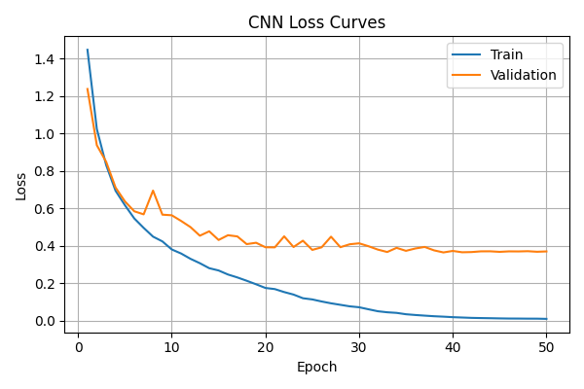
Observation
Training loss decreased smoothly from 1.4463 to 0.0099, while validation loss steadily decreased and stabilized around 0.37. The model converged after approximately 40 epochs.

Figure 2: CNN Training Accuracy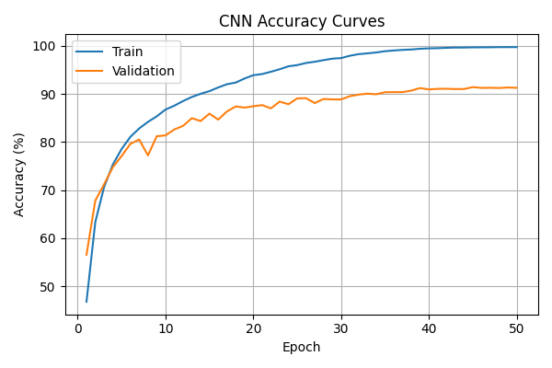
Observation
Validation accuracy improved from 56.58% to 91.44%. Training and validation curves remained closely aligned, indicating effective optimization and limited overfitting.

Figure 3: CNN Linear Probe
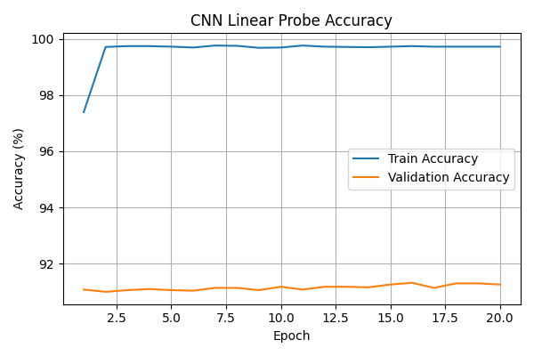
Observation
The CNN linear probe converges rapidly, reaching 91.32% validation accuracy while keeping the backbone frozen. The nearly flat validation curve after the first few epochs indicates that the pretrained ResNet18 features are already highly discriminative and linearly separable.

Figure 4: CNN Fine-tuning
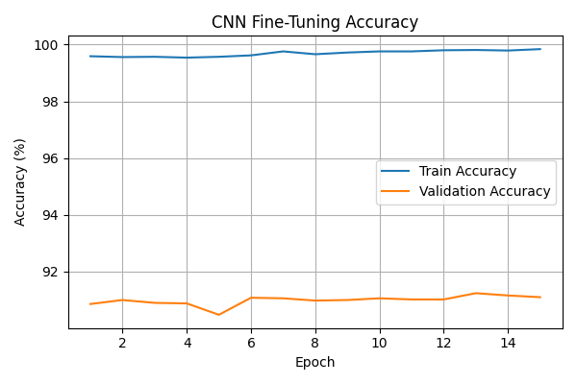
Observation
Fine-tuning maintains stable performance throughout training, achieving a peak validation accuracy of 91.24%. The small improvement over the initial epochs suggests that the supervised CNN backbone had already learned near-optimal representations prior to fine-tuning.
Figure 5: MAE Reconstruction Loss
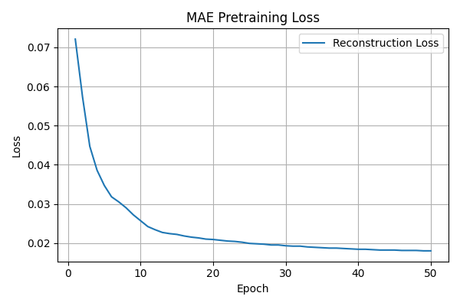
Observation
Reconstruction loss decreased from 0.0721 to 0.0180. Most improvements occurred during the first 30 epochs, after which the curve gradually saturated, indicating convergence.

Figure 6: MAE Linear Probe
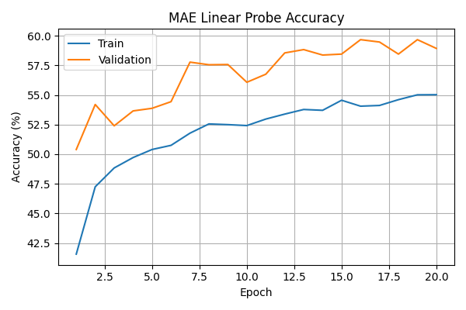
Observation
Validation accuracy improved steadily from 50.40% to 59.68%, demonstrating that the self-supervised encoder learned meaningful semantic representations despite not using labels during pretraining.

Figure 7: MAE LoRA Fine-Tuning
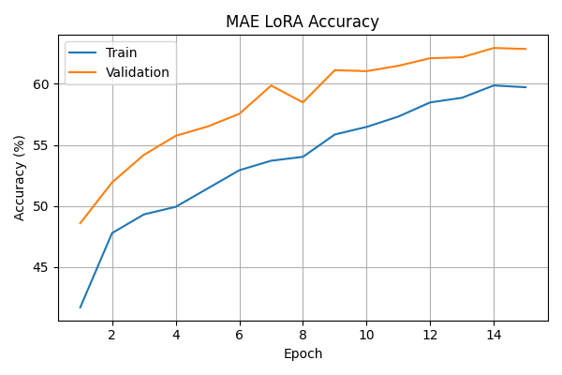
Observation
LoRA adaptation further improved performance from 59.68% to 62.94%, confirming that parameter-efficient adaptation can effectively refine learned representations.

Figure 8: I-JEPA Linear Probe
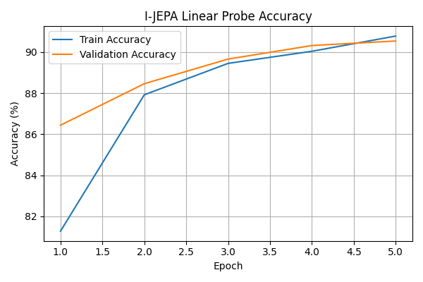
Observation
Validation accuracy increased from 86.44% to 90.54% in only five epochs. The strong probe performance indicates highly transferable semantic representations learned during self-supervised pretraining.

Figure 9: I-JEPA LoRA Fine-Tuning
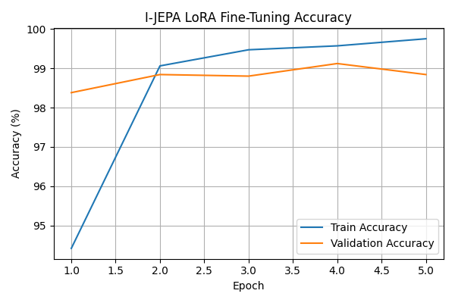
Observation
LoRA fine-tuning rapidly improved validation accuracy beyond 99%, producing the strongest downstream performance among all evaluated backbones.

6. Comparative Analysis
6.1 CNN: Supervised Training vs Linear Probe vs Fine-Tuning
Method | Accuracy (%)
Supervised Training | 91.44
Linear Probe | 91.32
Fine-Tuning | 91.24
The three results are nearly identical. This indicates that the ResNet18 backbone learned highly linearly separable representations. Additional adaptation provided minimal benefit because the supervised features were already near-optimal.

6.2 MAE: Linear Probe vs LoRA
Method | Accuracy (%)
Linear Probe | 59.68
LoRA Fine-Tuning | 62.94
LoRA improved performance by 3.26 percentage points. This demonstrates that parameter-efficient adaptation can successfully improve downstream performance without updating the full backbone.

6.3 Impact of Extended MAE Pretraining
Metric | Initial | Final
Reconstruction Loss | 0.0721 | 0.0180
Longer pretraining substantially improved representation quality. The reduction in reconstruction loss translated directly into stronger downstream classification performance.

6.4 CNN vs MAE
Metric | CNN | MAE
Probe Accuracy | 91.32 | 59.68
Adapted Accuracy | 91.24 | 62.94
The supervised CNN significantly outperformed MAE on CIFAR-10. Since CNN training directly optimizes classification performance using labels, it learns more discriminative representations for this dataset.

6.5 MAE vs I-JEPA
Metric | MAE | I-JEPA
Linear Probe | 59.68 | 90.54
Adapted Accuracy | 62.94 | 99.12
I-JEPA dramatically outperformed MAE. While MAE learns by reconstructing masked pixels, I-JEPA learns by predicting latent semantic representations. This leads to substantially stronger transferable features.

6.6 CNN vs I-JEPA
Metric | CNN | I-JEPA
Probe Accuracy | 91.32 | 90.54
Adapted Accuracy | 91.24 | 99.12
I-JEPA nearly matched CNN performance during linear probing and surpassed it after LoRA adaptation. These results suggest that predictive self-supervised learning can produce representations competitive with—and in this benchmark superior to—traditional supervised learning.

7. Conclusion
This benchmark compared supervised learning, reconstruction-based self-supervised learning, and predictive self-supervised learning on CIFAR-10.
Major findings include:
- ResNet18 achieved strong supervised performance with 90.34% test accuracy.
- MAE successfully learned useful representations without labels and benefited significantly from longer pretraining.
- LoRA consistently improved MAE downstream performance.
- I-JEPA produced highly transferable representations, achieving 90.54% linear probe accuracy.
- I-JEPA combined with LoRA achieved the strongest overall result, reaching 99.12% validation accuracy.
Overall, predictive self-supervised learning (I-JEPA) demonstrated the strongest representation quality among the evaluated backbones, while MAE highlighted the effectiveness of reconstruction-based pretraining and CNN provided a strong supervised baseline.

